Peaks on electron-density map that have smaller volume than reliably placed atom at some threshold level t1 can be considered as noise peaks and worth eliminating. To keep molecule related peaks (blob 1 on Fig. 1a), each noise peak is checked on lower threshold level t2 (Fig. 1b). If it does not merge to any blob that has big volume on previous threshold (blobs #0), it is eliminated on t2 threshold level. The algorithm described by Lunina et. al. (2003) was used to identify connected regions. Particular threshold levels are determined based on experience to achieve best performance of the procedure. Information between peaks on t2 threshold level may be eliminated or preserved.

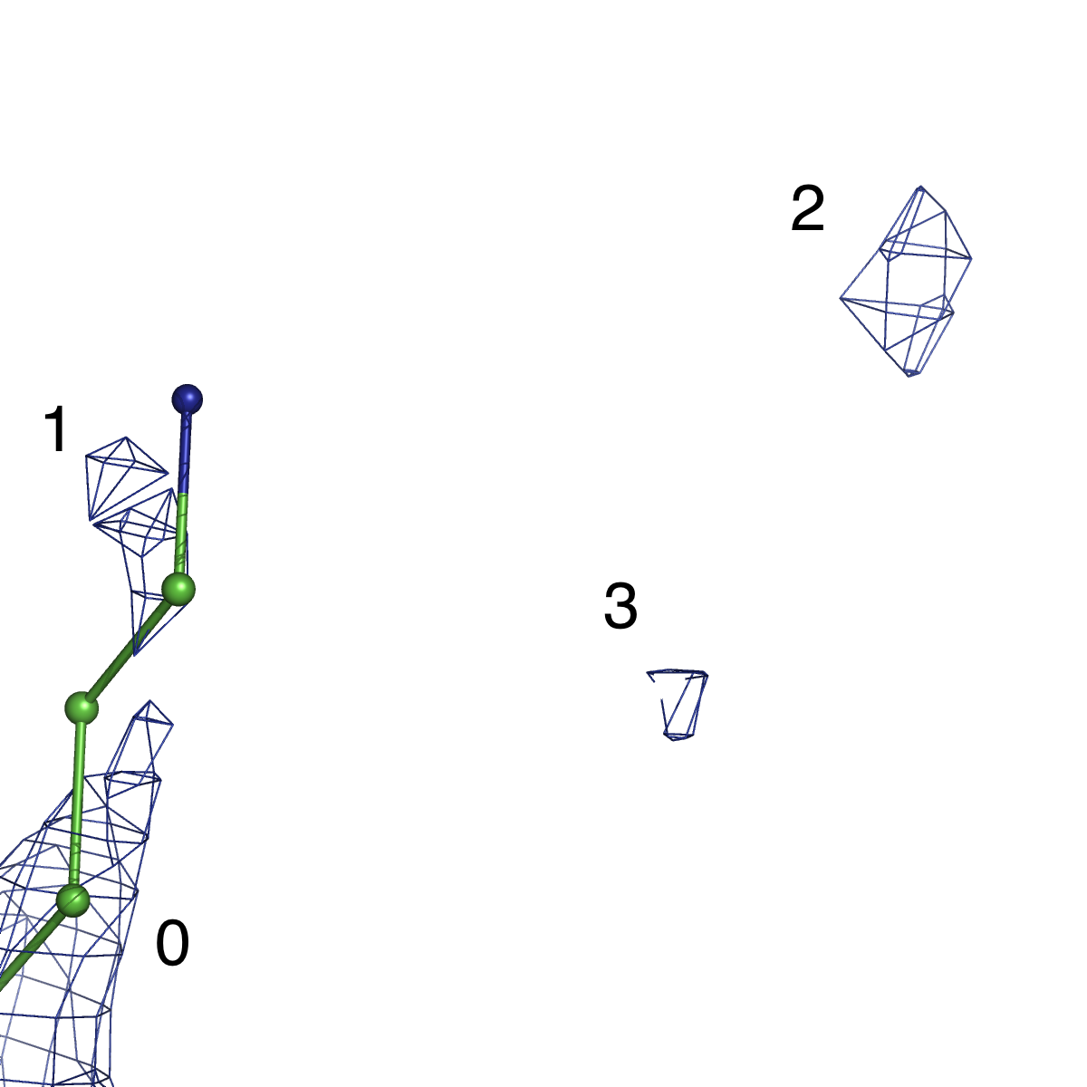 | 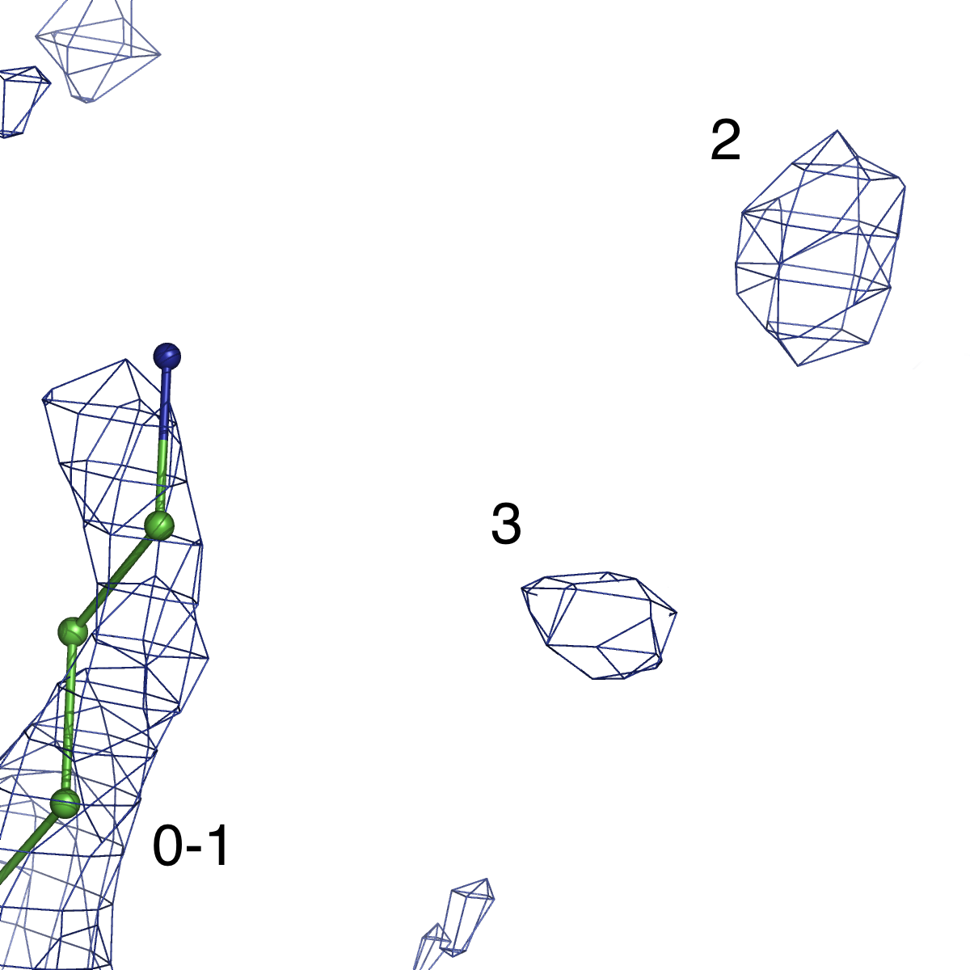
Fig. 1. Schematic illustration of noise peaks elimination: (a) the search of small volume peaks (blobs #1,2,3) (b) checking them at lower threshold level for merging with molecule-related peaks (blob #1). Blobs #2-3 should be eliminated.

